HANOI UNIVERSITY OF SCIENCE AND TECHNOLOGY
School of Information and Communications Technology

Software Requirement Specification

An Internet Media Store
Subject: TKXDPM
Group 9
Nguyễn Huy Hoàng-20226107
Nguyễn Trí Nam-20226093
Phạm Minh Đạt-20210169

Hanoi, 10-2025
Table of contents

1 Introduction 2
1.1 Objective 2
1.2 Scope 2
1.3 Glossary 3
1.4 References 4
2 Overall Description 5
2.1 Survey 5
2.2 Overall requirements 5
2.3 Business process 6
3 Detailed Requirements 12
3.1 Pay Order 12
3.2 View Product Detail 14
3.3 Add Product 16
3.4 Update Product 18
3.5 Place Order 20
3.6 Place Rush Order 22
3.7 Cancel Order 25
3.8 Add product to Cart 27
3.9 View Cart 29
3.10 Update Product In Cart 29
3.11 Remove products from Cart 31
3.12 Order Processing Review 32
3.13 Search Product 34
3.14 Manage User 35
3.15 Create New User 37
3.16 Update User Information 38
4 Supplementary specification 40
4.1 Functionality 40
4.2 Usability 40
4.3 Reliability 40
4.4 Performance 41
4.5 Supportability 41
4.6 Other requirements 41

Introduction
Các phần sau đây cung cấp tổng quan về Tài liệu Đặc tả Yêu cầu Phần mềm (SRS) cho dự án AIMS: An Internet Media Store. Tài liệu này nêu rõ các yêu cầu chức năng và phi chức năng cần thiết cho việc phát triển hệ thống. Nó đóng vai trò là tài liệu tham khảo cho các nhà phát triển, kiểm thử viên và các bên liên quan nhằm đảm bảo rằng phần mềm đáp ứng đúng mục đích đề ra. Tài liệu này tập trung vào việc xác định hệ thống phải làm gì, thay vì chi tiết thiết kế hay cách thức triển khai.

Objective
Mục tiêu của tài liệu này là xác định các yêu cầu của hệ thống AIMS: An Internet Media Store. Tài liệu đóng vai trò như một thỏa thuận chính thức giữa các bên liên quan, nhà phát triển và kiểm thử viên nhằm đảm bảo sự hiểu biết rõ ràng về các khả năng của hệ thống.Đối tượng bao gồm:
- Software Developers: Để triển khai các chức năng theo yêu cầu đã được chỉ định.
- Project Managers & Product Owners: Để xác nhận yêu cầu và theo dõi tiến độ.
- Testers: Để thiết kế các trường hợp kiểm thử dựa trên yêu cầu.
- End Users & Business Stakeholders: Để xác nhận rằng phần mềm phù hợp với nhu cầu kinh doanh.
Tài liệu này đảm bảo rằng tất cả các bên liên quan đều có hiểu biết rõ ràng về yêu cầu và kỳ vọng của hệ thống trước khi quá trình phát triển bắt đầu.S

Scope
An Internet Media Store là một ứng dụng thương mại điện tử dựa trên máy tính để bàn Được thiết kế để bán và quản lý các sản phẩm truyền thông vật lý, bao gồm sách, CD, đĩa LP và DVD. Phần mềm cho phép tương tác liền mạch giữa khách hàng, quản lý sản phẩm và quản trị viên, đồng thời đảm bảo đáp ứng các tiêu chuẩn về hiệu suất, tính khả dụng và bảo mật.
- Tính năng chính:
- Product Management Người quản lý sản phẩm có thể thêm, chỉnh sửa, xóa và cập nhật sản phẩm truyền thông trong khi vẫn tuân thủ các quy tắc kinh doanh (ví dụ: hạn chế về giá, hạn chế về kho).
- User Management: Quản trị viên có thể tạo, sửa đổi và xóa tài khoản người dùng, chỉ định vai trò và đặt lại mật khẩu.
- Shopping & Ordering: Khách hàng có thể tìm kiếm sản phẩm, xem chi tiết, thêm cho chúng vào giỏ hàng và tiến hành thanh toán.
- Payment Processing: Thanh toán mặc định với VietQR, có thể dùng thẻ tín dụng PayPal
- Order Management: Có sẵn dịch vụ giao hàng tiêu chuẩn và tính năng tính phí vận chuyển tự động
- Delivery: Có sẵn dịch vụ giao hàng tiêu chuẩn và tính năng tính phí vận chuyển tự động
- Security & Logging: Hệ thống lưu giữ nhật ký về các sửa đổi sản phẩm và hành động quản trị, đảm bảo tính minh bạch và khả năng truy xuất nguồn gốc..
- Exclusions:
- Thanh toán chỉ hỗ trợ bằng QR và thẻ tín dụng và có thể mở rộng trong tương lai.
- Hiện tại AIMS chỉ hỗ trợ các sản phẩm vật lí

Phần mềm này dành cho các doanh nghiệp bán lẻ, cho phép quản lý hàng tồn kho, xử lý đơn hàng và giao dịch an toàn, đảm bảo độ tin cậy và khả năng mở rộng

Glossary
No | Term | Explanation | Example | Note
1 | VAT | Thuế Giá Trị Gia Tăng (VAT) là một loại thuế tiêu dùng được áp dụng vào giá bán của sản phẩm. | 10% VAT | Hệ thống tính toán và cộng thuế Giá Trị Gia Tăng (VAT) vào giá hóa đơn.
2 | Invoice | Hóa đơn hiển thị chi tiết sản phẩm, giá, thuế, phí giao hàng và tổng thanh toán. | Hóa đơn gồm chi tiết về sản phẩm , số tiền, thời gian .... | Được hiển thị trước khi khách xác nhận thanh toán.
3 | API  (Application Programming Protocol) | Một tập hợp các quy tắc, giao thức và công cụ cho phép các ứng dụng phần mềm khác nhau giao tiếp với nhau. | VietQR API | AIMS hỗ trợ thánh toán qua QR
4 | VietQR | Một cổng thanh toán trực tuyến của Việt Nam được sử dụng để xử lý các giao dịch thẻ tín dụng trong hệ thống AIMS. | VietQR API | Hỗ trợ quét mã bằng QR
5 | PayPal | Cổng thanh toán quốc tế được minh triển khai qua SanBox | PayPal Sandbox | Mô phỏng việc thanh toán qua PayPal
6 | Checkout | Quá trình khách hàng nhập thông tin giao hàng và hoàn tất thanh toán. | Nhập thông tin giao hàng | Bao gồm thông tin giao hàng và thanh toán
7 | Session | Một khoảng thời gian tương tác tạm thời giữa người dùng và hệ thống, trong đó người dùng truy cập và thao tác với phần mềm hoặc trang web, và hệ thống duy trì các thiết lập cũng như thông tin liên quan. | software session
8 | Authentication | Quy trình xác minh danh tính của quản lí trước khi đăng nhập. | Đăng nhập với tài khoản và mật khẩu | So sánh với cơ sở DL.
9 | Credit card | Thẻ tín dụng để thanh toán cho sản phẩm | Thẻ VISA | Mô phỏng việc nhập thông tin thẻ
10 | VISA Card | Thẻ Visa là một loại thẻ thanh toán quốc tế do tổ chức Visa Inc. cung cấp, được các ngân hàng liên kết phát hành. | Thẻ VISA | Có nhiều loại thẻ như tín dụng, ghi nợ, trả trước

References
- IT4549E: Software Design and Construction - Nguyen Thi Thu Trang, trangntt@soict.hust.edu.vn.

Overall Description

Survey
Hệ thống này là một cửa hàng truyền thông trực tuyến được thiết kế để giúp khách hàng mua các sản phẩm truyền thông kỹ thuật số một cách thuận tiện. Phần mềm này hoạt động như một nền tảng toàn diện, không chỉ phục vụ khách hàng mà còn cho cả các nhà quản lý sản phẩm.
Hệ thống bao gồm ba tác nhân chính:
- Customer: Khách hàng có thể xem, tìm kiếm và sắp xếp sản phẩm trong cửa hàng. Để mua hàng, khách hàng phải thêm hoặc cập nhật sản phẩm trong giỏ hàng và cung cấp thông tin giao hàng. Sau khi nhập chính xác thông tin, khách hàng có thể tiến hành thanh toán qua QR hoặc thẻ ngân hàng. Sau khi giao dịch thành công, AIMS sẽ gửi email xác nhận kèm theo hóa đơn.
- Product Manager: Sử dụng giao diện quản lý do AIMS cung cấp, quản lý sản phẩm có thể giám sát hiệu quả hàng tồn kho của cửa hàng. Họ có toàn quyền kiểm soát việc thêm, xóa và cập nhật chi tiết sản phẩm. Ngoài ra, họ có thể quản lý các đơn hàng đang chờ xử lý bằng cách phê duyệt hoặc từ chối chúng.
- Administrator: Quản trị viên có quyền quản lý người dùng trong hệ thống. Họ có thể tạo tài khoản người dùng mới, cập nhật thông tin người dùng và chặn hoặc bỏ chặn người dùng khi cần thiết.

Overall requirements
Biểu đồ Trường hợp sử dụng cho thấy cách các tác nhân tương tác với các trường hợp sử dụng khác nhau trong hệ thống. Nó thể hiện các yêu cầu chức năng của hệ thống bằng cách minh họa sự tương tác giữa các tác nhân bên ngoài và bên trong.
Sơ đồ dưới đây trình bày sơ đồ trường hợp sử dụng chung của phần mềm AIMS, làm nổi bật các tác nhân và các trường hợp sử dụng liên quan. 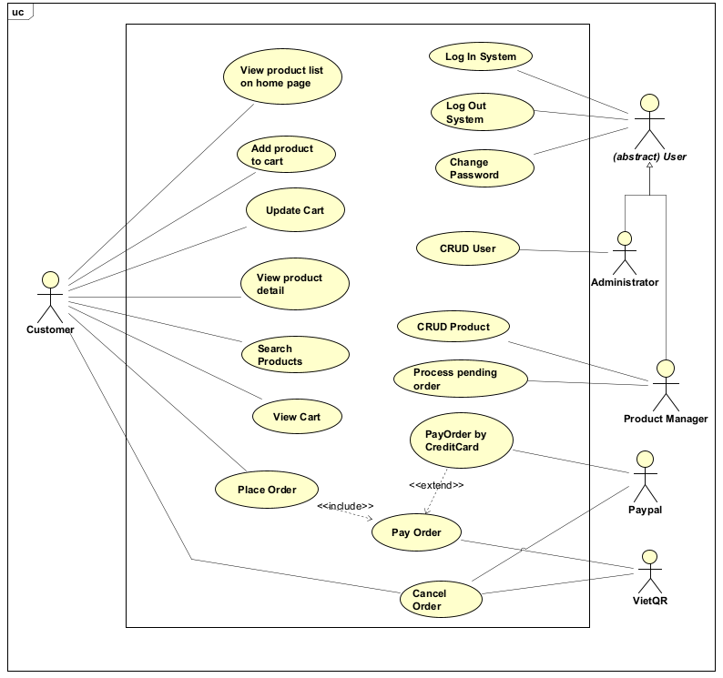

Business process
Trong phần mềm AIMS, năm hoạt động nghiệp vụ cốt lõi được xác định bao gồm: “Quy trình quản lý sản phẩm” ,“Quy trình quản lý người dùng” , “Quy trình mua hàng” Mỗi hoạt động này đều được minh họa chi tiết bằng biểu đồ hoạt động (activity diagram) trong phần tương ứng của nó. Dưới đây là các biểu đồ hoạt động thể hiện tất cả các use case trong phần mềm AIMS.
Biểu đồ hoạt động (Activity diagrams) được sử dụng để mô hình hóa các quy trình nghiệp vụ vì chúng cung cấp một biểu diễn trực quan có cấu trúc của luồng công việc, các điểm ra quyết định và việc phân bổ tài nguyên. Những biểu đồ này giúp các bên liên quan hiểu, phân tích và tinh chỉnh các quy trình phức tạp bằng cách mô tả trình tự các hoạt động, sự song song, xử lý lỗi và sự tích hợp với các mô hình khác. Ngoài ra, chúng còn đóng vai trò là công cụ tài liệu hiệu quả, giúp tăng cường giao tiếp và hợp tác giữa các bên liên quan.
2.3.1) Quy trình quản lí sản phẩm
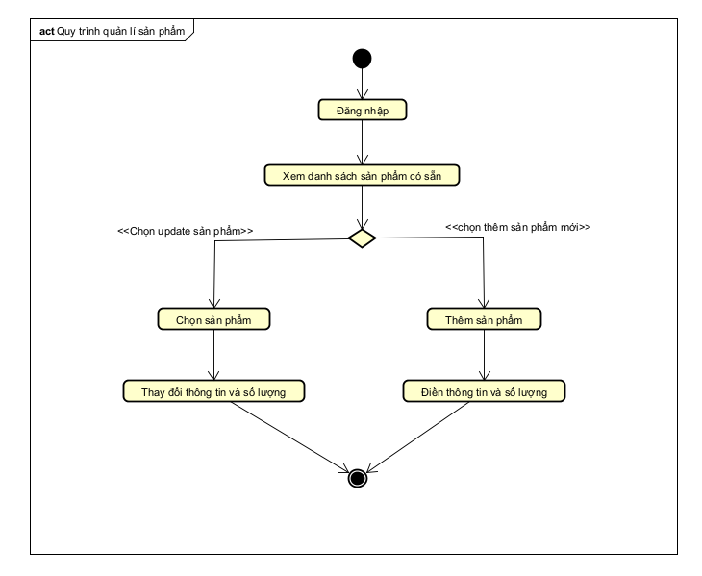
2.3.2) Quy trình mua hàng
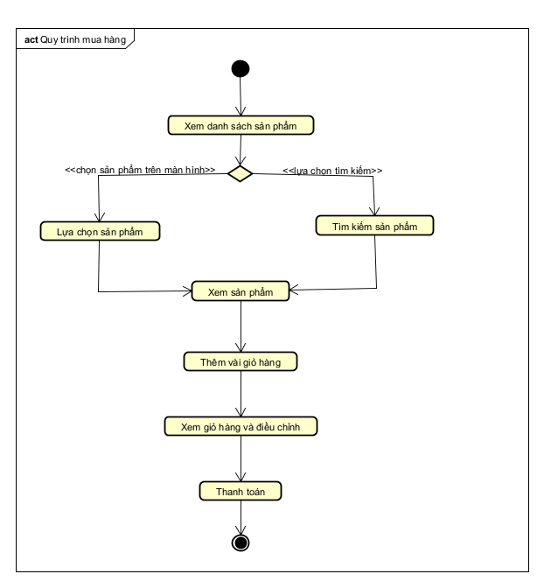
2.3.3) Quy trình quản lí người dùng
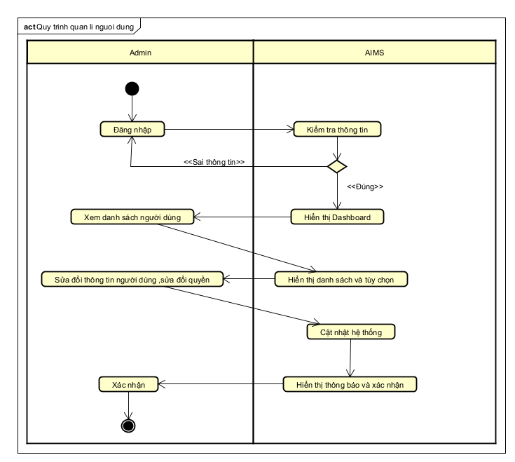
2.3.1 Business operation- Pay Order
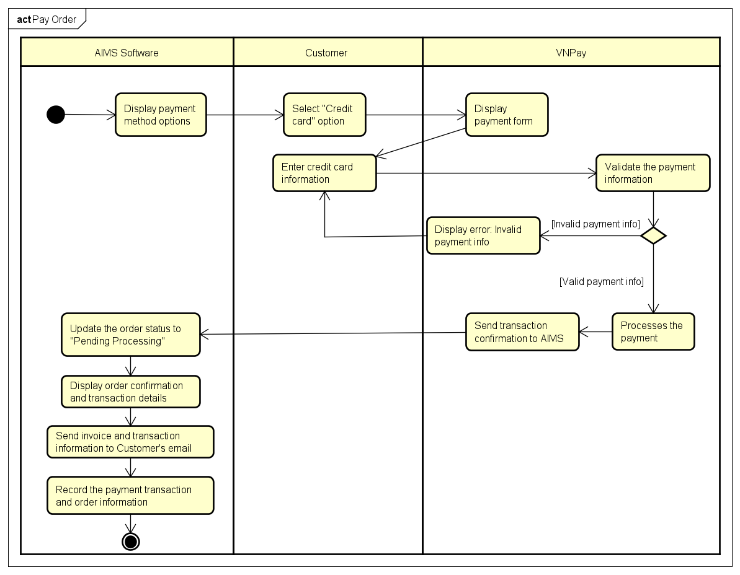2.3.2 Business operation- View Product Detail
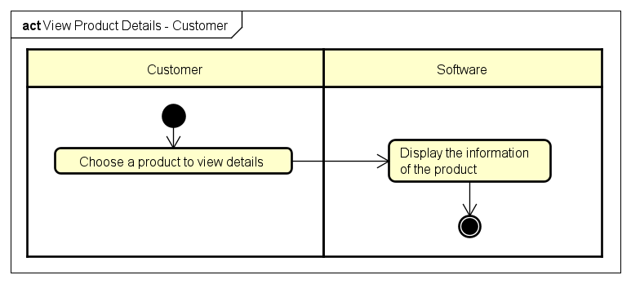

2.3.3 Business operation- Add Product
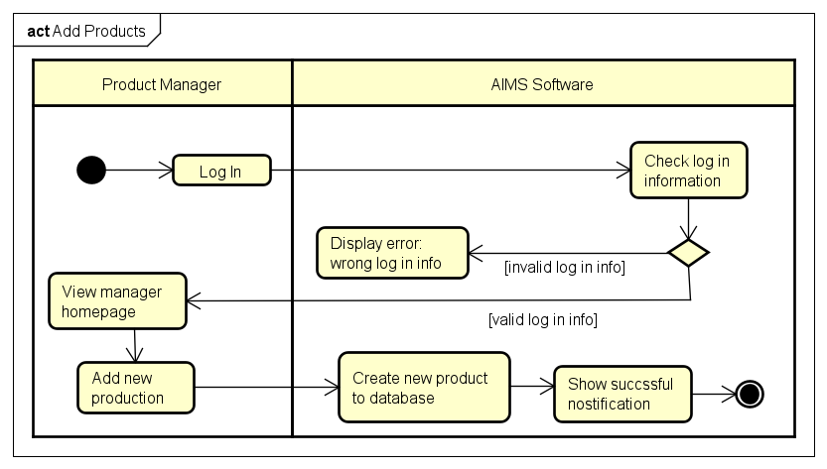
2.3.4 Business operation- Update Product
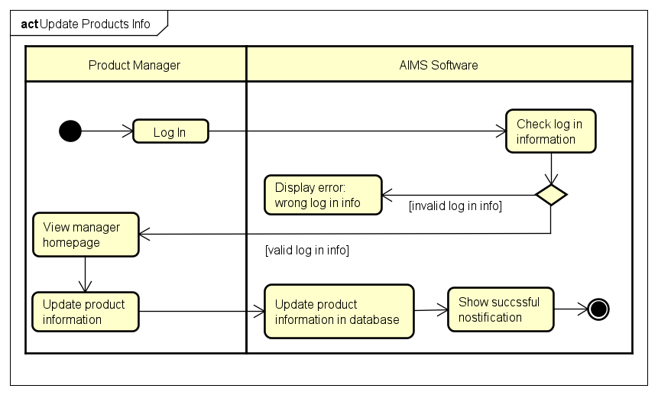

2.3.5 Business operation- Place Order
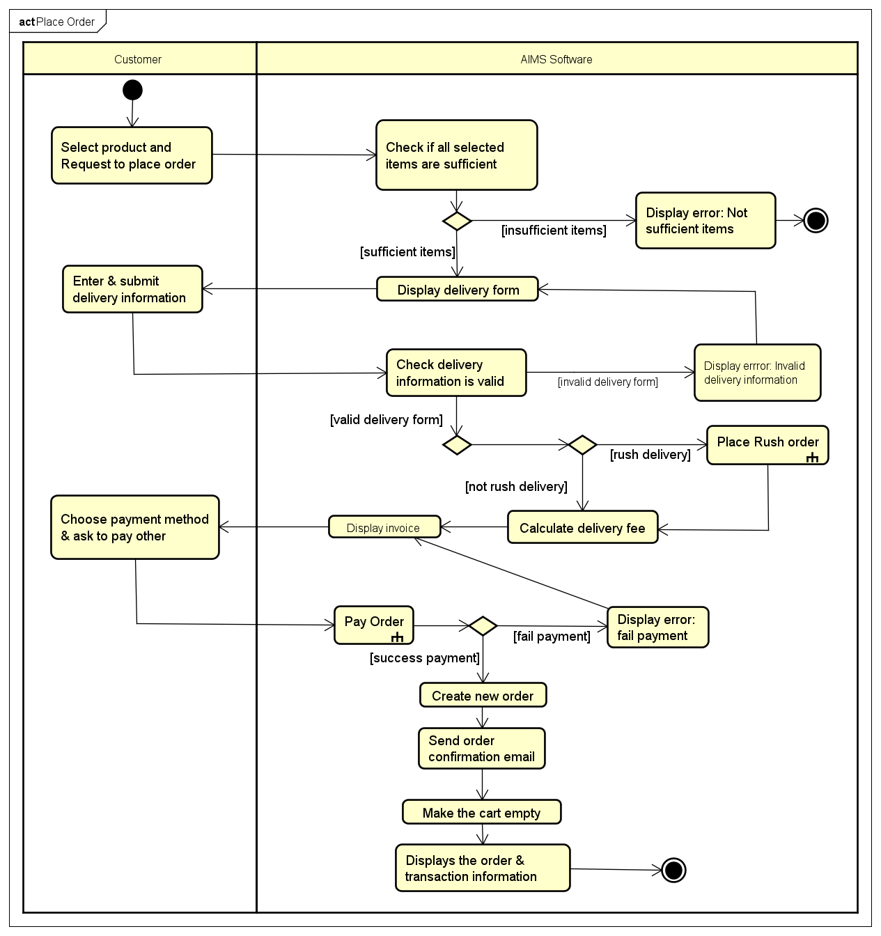

2.3.6 Business operation- Place Rush Order
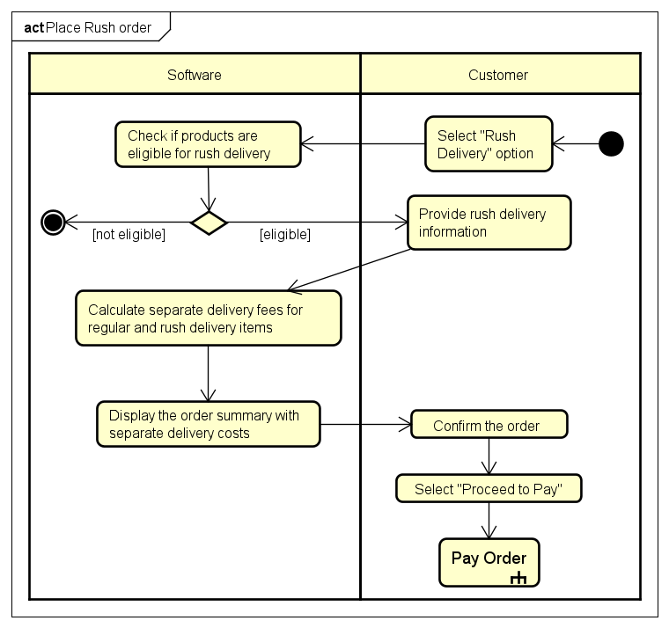

2.3.7 Business operation- Cancel Order
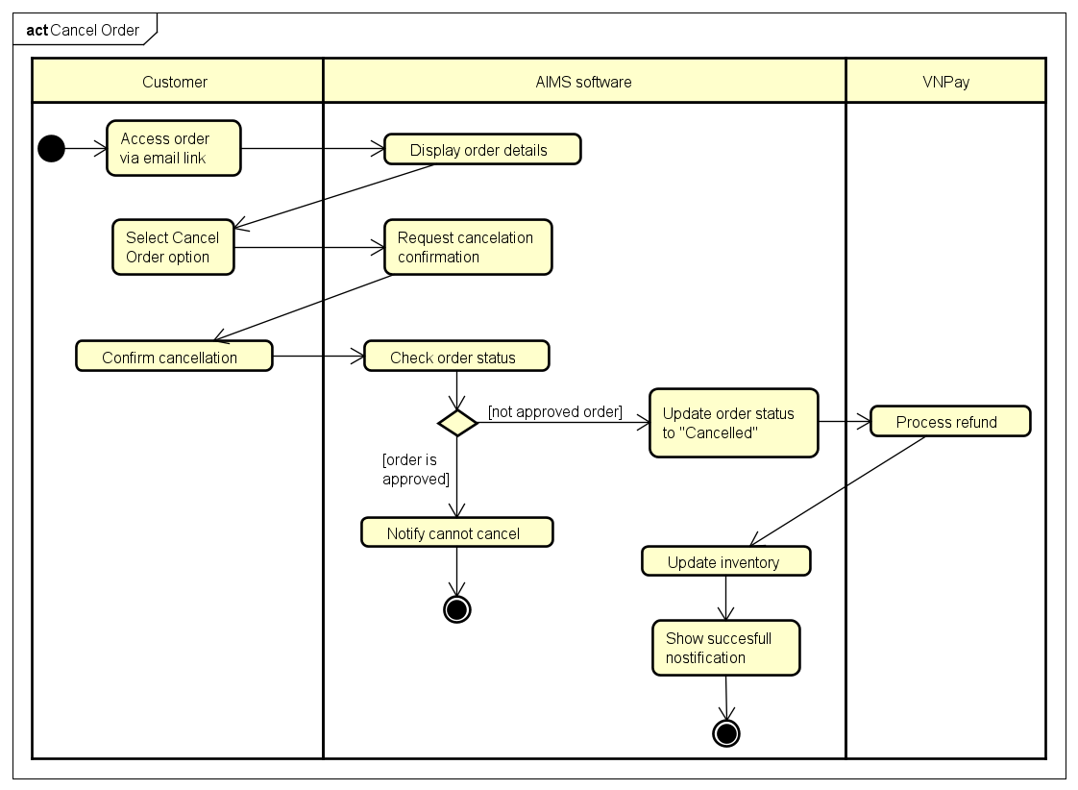

2.3.8 Business operation- Add product to Cart
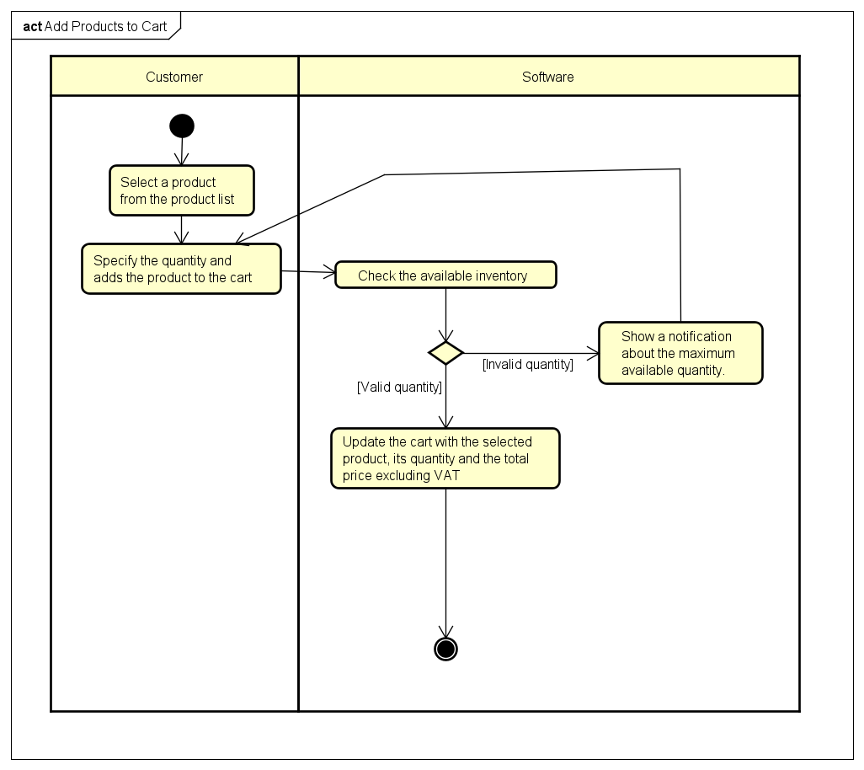
2.3.9 Business operation- View Cart
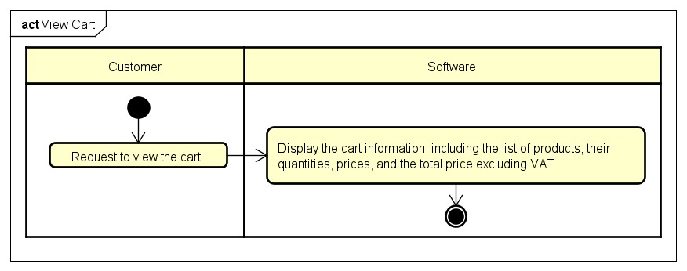

2.3.10 Business operation- Update Cart
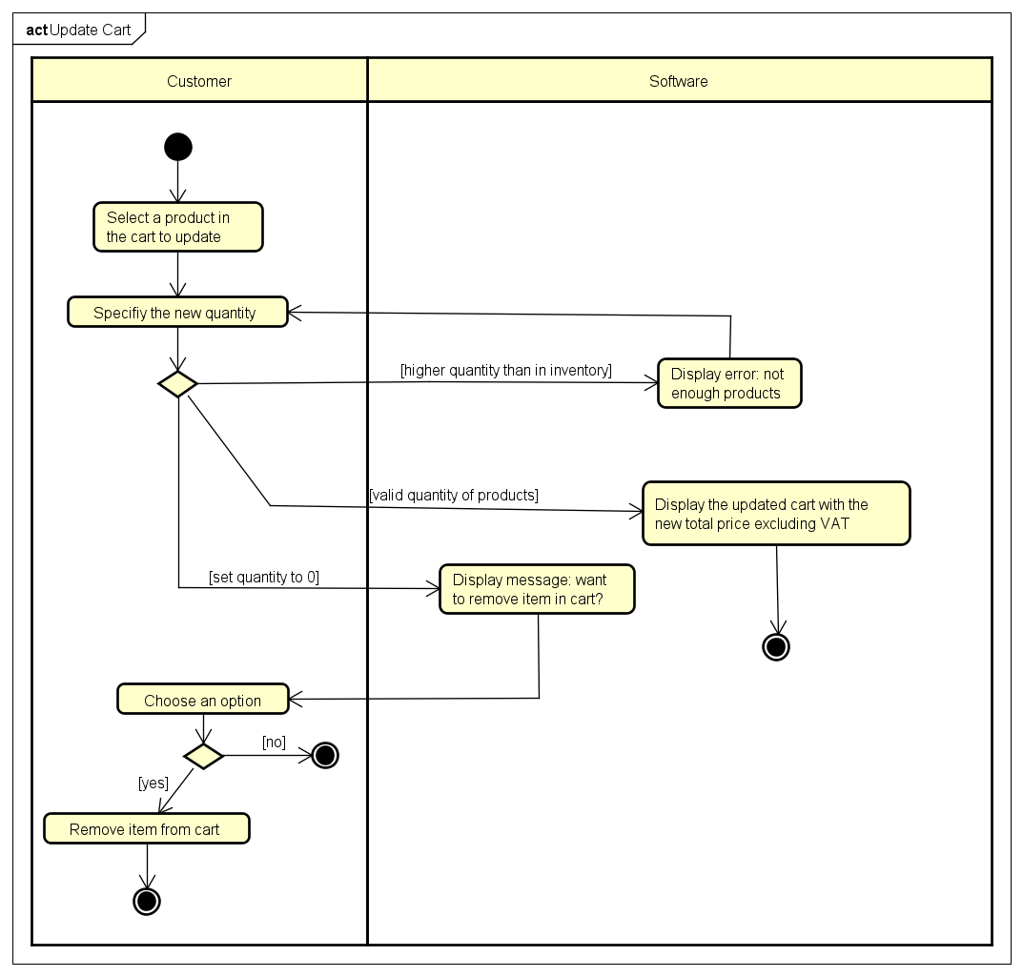

2.3.11 Business operation- Process Pending Order
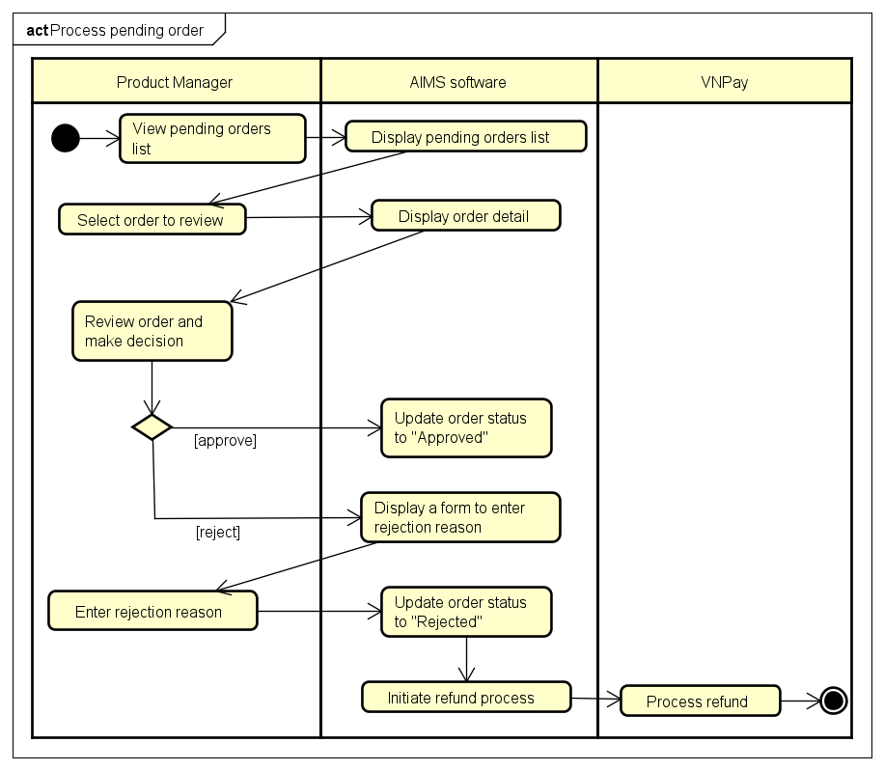

2.3.12 Business operation- Search Product
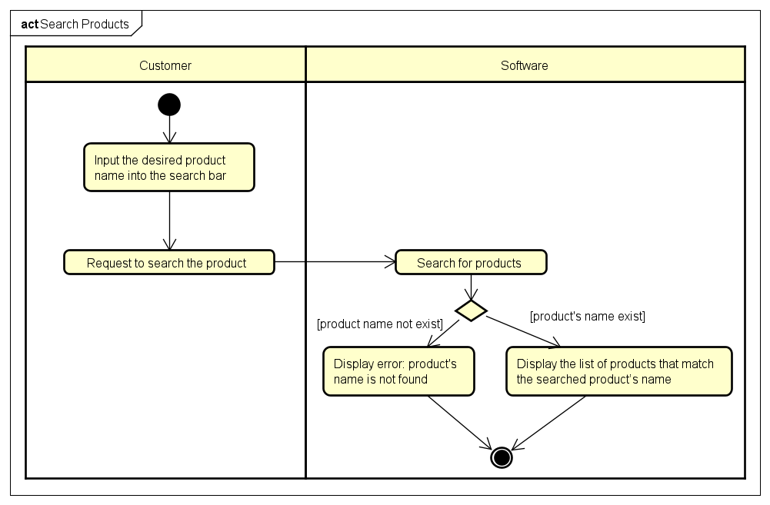

2.3.13 Business operation- Create User
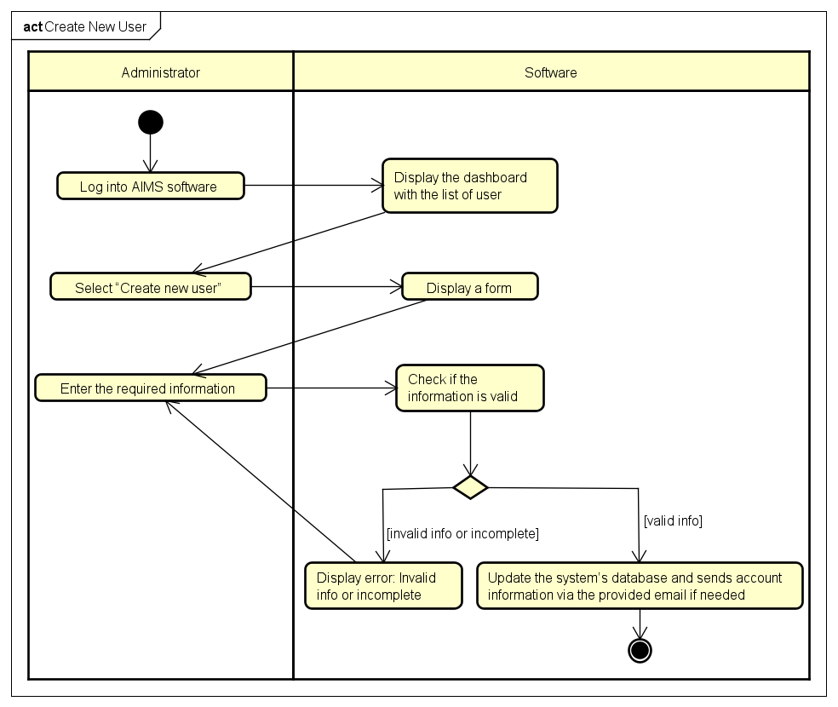

2.3.14 Business operation- Update User
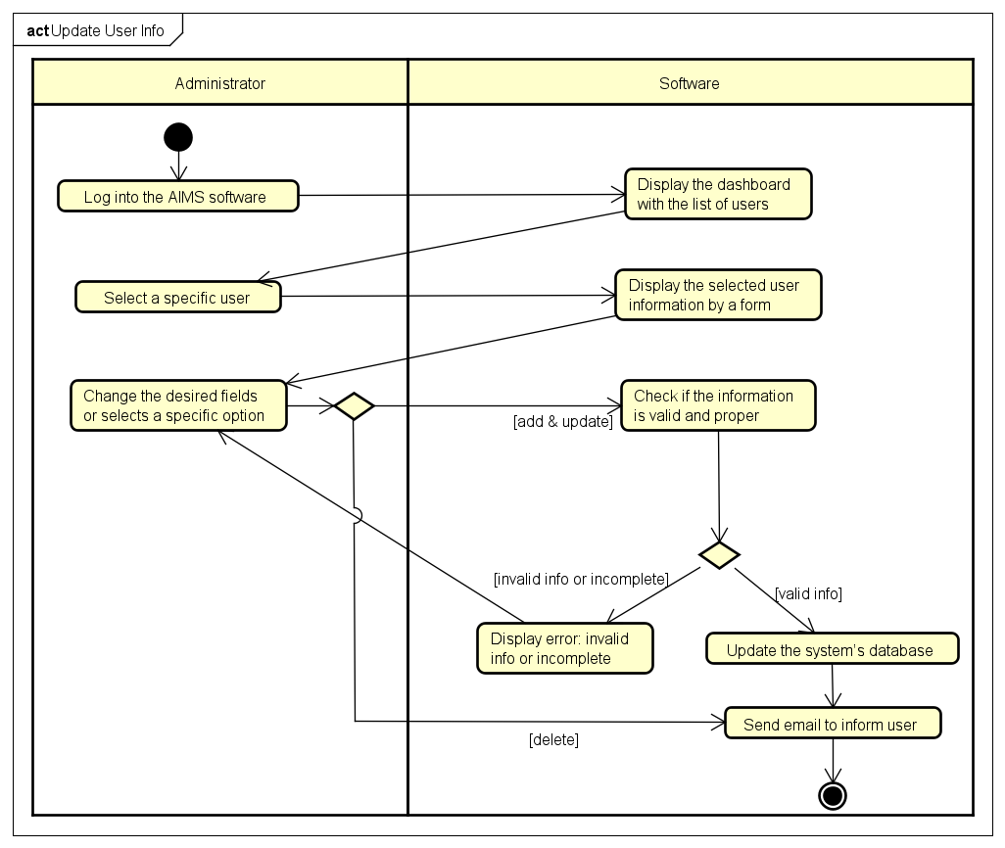

Detailed Requirements
Detailed requirements typically outline specific descriptions of functionalities, features, user interactions, system behavior, performance criteria, constraints, and dependencies within a software system. They serve as a core foundation for software development, covering both functional and non-functional aspects of the system.

Pay Order
Use Case “Pay Order”
- Use case code
UC001
- Brief Description
This use case describes the interaction between customers, software and VNPay when the customer wishes to pay an order.
- Actors
  - Customer
  - VNPay
- Preconditions
- The customer submitted delivery information
- AIMS computed the total payable amount.
- Basic Flow of Events
- AIMS software displays the invoice.
- Customer asks to pay the invoice
- AIMS software redirects to VNPay
- VNPay sends payment result to VNPay
- AIMS software saves invoice and payment transaction
- VNPay notifies the payment result
- Alternative flows
Table -Alternative flows of events for UC Pay Order
No | Location | Condition | Action | Resume location
1. | At Step 5 | If the customer cancels the payment transaction | - AIMS software notifies that the payment transaction is canceled | At Step 1
2. | At Step 5 | If the credit card is invalid | - AIMS software notifies that the credit card is invalid to take payment transaction | At Step 1
3. | At Step 5 | If the balance is insufficient | - AIMS software notifies that the balance is insufficient to complete the order. | At Step 1
- Input data
Table A - Input data of Credit Card Information
No | Data fields | Description | Mandatory | Valid condition | Example
1. | Card Number | Credit card number | Yes | Valid card number format | 411111111111111
2. | Cardholder Name | Name on card | Yes | Non-empty string | NGUYEN VAN A
3. | Expiration Date | Card expiry date | Yes | Valid MM/YY format | 12/25
4. | CVC/CVV | Card verification code | Yes | 3-4 digit number | 123
- Output data
Table B - Output data of Payment Confirmation
No | Data fields | Description | Display format | Example
 | Order Summary | General order information | Text | Customer: Nguyen Van A  Phone: 0912345678  Address: 123 Tran Phu, Hanoi  Total: 132,000 VND
 | Transaction ID | Unique payment identifier | Alphanumeric | CD "Greatest Hits", 1, 150,000 VND
 | Transaction Content | Payment description | Text | 250,000 VND
 | Transaction Datetime | Time of payment | Date/Time | 15/02/2023 14:30:25
- Postconditions
1. Order is created and saved with status "Pending Processing"
2. Inventory is updated to reserve ordered products
3. Payment transaction is recorded
4. Invoice and transaction details are sent to Customer's email

View Product Detail
Use Case “View Product Detail”
- Use case code
UC002
- Brief Description
This use case describes the interaction between customer and AIMS system when customer wishes to view detail information of products
- Actors
  - Customers or Product Manager
- Preconditions
The customer has navigated to the product list or product detail screen.
- Basic Flow of Events
- The user chooses a product to view details
- The AIMS software displays the information of the product
- Alternative flows
None
- Input data
None
- Output data
Table A - Common information of product in all category:
No | Data fields | Description | Display format | Example
1. | Title | Name of product | String | ‘Star War’
2. | Price | Price of product
3. | Category | Category of product | String | ‘book’
4. | Avail | Number of products available in store | Non-negative integer | 5
5. | Image | Image of product | Image(.png file or .jpg file)

Table B -Information of book:
No | Data fields | Description | Display format | Example
1. | Author | Author of the book | String | Vu Hai Dang
2. | Publisher | Publisher of the book | String | Fraternity
3. | Cover Type | Type of the cover | String | Paperpack
4. | Number of Page | Number of pages | Positive integer | 5
5. | Publication Date | Date when book is publicated | Date (Year-Month-Day) | 2025-02-27
6. | Language | Language of book content | String | English
7. | Genre | Genre type of book | String | Horror

Table C -Information of DVDs:
No | Data fields | Description | Display format | Example
1. | Disc Type | Type of DVD | String | HD-DVD
2. | Director | Director of DVD | String | Steven Sqielberg
3. | Studio | Studio publishing the movie in the DVD | String | Walt Disney
4. | Language | Language in the move | String | English
5. | Subtitle | Subtitle language | String | Germany
6. | Release date |  | Date (Year-Month-Day) | 2025-02-27
7. | Genre | Main genre of movie | String | Comedy

Table D - Information of CDs:
No | Data fields | Description | Display format | Example
1. | Artist | Name of Artist | String | Selena Gomez
2. | Record Label |  | String | Warner Music
3. | Genre | Genre in the move | String | Pop
4. | Release date |  | Date (Year-Month-Day) | 2025-02-27
5. | Track list | List of the song in the CD | String | 1, Call me weh you  break up  2, Scared of losing  you
.
- Postconditions
The software displays the information of product.

Add Product
Use Case “Add Product”
- Use case code
UC003
- Brief Description
This use case describes the interaction between the Product Manager and AIMS when adding a new product to the store
- Actors
  - Product Manager
- Preconditions
- The Product Manager must be logged in.
- The Product Manager has the necessary permissions to add products.
- Basic Flow of Events
- The Product Manager selects the option to add a new product.
- The AIMS software displays the product entry form.
- The Product Manager enters product details (title, category, value, price, etc.).
- The AIMS software validates the input fields.
- The Product Manager submits the form.
- The AIMS software stores the new product in the database.
- The AIMS software confirms the successful addition of the product.
- The system updates the product list.
- Alternative flows
Table N-Alternative flows of events for UC Add Product
No | Location | Condition | Action | Resume location
1. | At Step 3 | If any required field is missing or incorrect | - AIMS software highlights invalid fields | At Step 2
- Input data
Table A-Input data for Adding a Product
No | Data fields | Description | Mandatory | Valid condition | Example
- 1 | Title | Name of the product | Yes | Non-empty string | “Dune”
2. | Category | Product category | Yes | Selected from predefined list | Book
3. | Value | Base price of the product (before VAT) | Yes | Positive number | 100,000
4. | Price | Selling price (before VAT) | Yes | Between 30%-150% of Value | 120,000
5. | Barcode | Unique product identifier | Yes | Alphanumeric string | 1234567890
6. | Description | Short product description | No | String | Classic novel
7. | Quantity | Number of items available in stock | Yes | Non-negative integer | 50
8. | Warehouse Entry Date | Date the product was added to inventory | Yes | Valid date format (YYYY-MM-DD) | 2025-02-28
9. | Dimensions | Product dimensions (L x W x H) | Yes | Numeric values in cm | 20x15x5 cm
10. | Weight | Product weight | Yes | Numeric value in kg | 0.5 kg

- Output data
Table B-Output data for Adding a Product
No | Data fields | Description | Display format | Example
1. | Product name | Name of product | Text | Dune
2. | Price | Selling price (before VAT) | Currency | 120,000
3. | Category | Category of product | String | ‘book’
4. | VAT | 10% of the selling price | Currency | 12,000
5. | Total price | Price including VAT | Currency | 132,000
6. | Stock quantity | Available units | Integer | 40
- Postconditions
- The newly added product is stored in the system.

Update Product
Use Case “Update Product”
- Use case code
UC004
- Brief Description
This use case describes the interaction between the Product Manager and AIMS when updating product details in the store
- Actors
  - Product Manager
- Preconditions
- The Product Manager must be logged in.
- The Product Manager has the necessary permissions to update products.
- Basic Flow of Events
- The Product Manager selects a product to update.
- The AIMS software displays the product details.
- The Product Manager edits product details (title, category, value, price, etc.).
- The AIMS software validates the updated input fields.
- The Product Manager submits the updates.
- The AIMS software stores the updated product details in the database.
- The AIMS software confirms the successful update of the product.
- The system updates the product listing.
- Alternative flows
Table Alternative flows of events for Updating a Product
No | Location | Condition | Action | Resume location
1. | At Step 3 | If any required field is missing or incorrect | - AIMS software highlights invalid fields | At Step 2
2. | At Step 6 | If more than 30 products have been added in a day | - AIMS software displays a restriction message and denies the request | Use case ends
- Input data
Table A-Input data for Updating a Product
No | Data fields | Description | Mandatory | Valid condition | Example
- 1 | Title | Updated name of the product | No | Non-empty string | “Dune 2”
2. | Price | Updated selling price | No | Between 30%-150% of Value | 150,000
- Output data
Table B-Output data for Updating a Product
No | Data fields | Description | Display format | Example
1. | Updated name | Name of product | text | Dune 2
2. | Updated Price | Selling price (before VAT) | Currency | 150,000
3. | Category | Category of product | String | ‘book’
4. | VAT | 10% of the selling price | Currency | 12,000
5. | Total price | Price including VAT | Currency | 132,000
6. | Stock quantity | Available units | Integer | 40
- Postconditions
- The updated product details are stored in the system.

Place Order
Use Case “Place Order (Customer)”
- Use case code
UC005
- Brief Description
This use case describes the interaction between Customer and AIMS when Customer wishes to place an order for products in their cart.
- Actors
  - Customer
- Preconditions
The cart needs not to be empty and they must be in the working session.
- Basic Flow of Events
- Customer selects products and requests to place order in the cart
- The AIMS software checks the availability of products in the cart
- The AIMS software displays the form of delivery information with order information
- Customer enters and submits delivery information
- Software checks the delivery information
- The AIMS software calculates delivery fee and updates order information with shipping fees
- The customer selects to payment method and asks to pay order
- The AIMS software calls UC “Pay order”
- The AIMS software creates and saves a new order
- The AIMS software sends email about the order notification and information
- The AIMS software makes the cart empty
- The AIMS software displays the successful order notification, the order and the transaction information.
- Alternative flows
Table N-Alternative flows of events for UC Place order
No | Location | Condition | Action | Resume location
1. | At Step 2 | If inventory is insufficient for any product | - The software displays the inventory quantity for each insufficient product  - The Customer is prompted to update cart quantities | Use case ends
2. | At Step 5 | If delivery information is invalid or incomplete | - The software highlights invalid fields  - The Customer is prompted to correct information | Resumes at Step 3
3. | At Any Step | If Customer selects "Back" | - The system returns to the cart screen | Use case ends
4. | At Any Step | If Customer exits the software | - The ordering process is terminated | Use case ends
5 | At Step 6 | If the user chooses to place a rush order | - AIMS software inserts use case “Place rush order” | At Step 7
- Input data
Table A-Input data of Delivery Information
No | Data fields | Description | Mandatory | Valid condition | Example
1. | Recipient name | Full name of recipient | Yes | Non-empty string | Nguyen Van A
2. | Email | Contact email | Yes | Valid email format | example@mail.com
3. | Phone number | Contact phone number | Yes | Valid phone number ? | 0912345678
4. | Province/City | Delivery province/city | Yes | From provided list | Hanoi
5. | District | Delivery district |  |  | Hoan Kiem
6. | Delivery address | Detailed address | Yes | Non-empty text | 123 Tran Phu Street
7. | Delivery Method | Regular or Rush | Yes | "Regular" or "Rush" | Regular
- Output data
Table B-Output data of Order Summary
No | Data fields | Description | Display format | Example
 | Product list | List of products | Table with columns: Name, Quantity, Unit Price | Book "The Art of War", 1, 100,000 VND
 | Subtotal | Sum of all product prices excluding VAT | Currency | 100,000 VND
 | VAT | 10% of subtotal | Currency | 10,000 VND
 | Total Products with VAT | Subtotal + VAT | Currency | 110,000 VND
 | Delivery Fee | Calculated based on weight and location | Currency | 22,000 VND
 | Total amount | Final amount to be paid  (Total Products with VAT + Delivery Fee) | Currency | 132,000 VND
- Postconditions
1. Order information is temporarily stored
2. The system proceeds to the payment process.

Place Rush Order
Use Case “Place Rush Order”
- Use case code
UC006
- Brief Description
This use case describes the interaction between Customer and AIMS when Customer wishes to place a rush order for delivery within 2 hours to an eligible location.
- Actors
  - Customer
- Preconditions
Customer has added products to the cart
- Basic Flow of Events
- The Customer selects "Rush Delivery" option
- The software checks if products are eligible for rush delivery
- The Customer provides rush delivery information
- The software calculates separate delivery fees for regular and rush delivery items
- The software displays the order summary with separate delivery costs
- The Customer confirms the order
- The Customer selects "Proceed to Pay"
- The use case ends, transitioning to "Pay Order" use case
- Alternative flows
Table Alternative flows of events for UC Place order
No | Location | Condition | Action | Resume location
1. | At Step 6 | If delivery address doesn't support rush delivery | - The software notifies Customer  - Customer is prompted to choose regular delivery or update address | Resumes at Step 4
2. | At Step 7 | If no products are eligible for rush delivery | - The software notifies Customer  - Customer is prompted to choose regular delivery | Resumes at Step 5
3. | At Step 7 | If only some products are eligible for rush delivery | - The software displays which products are eligible  - Customer can choose to proceed with mixed delivery or update selections | Resumes at Step 8
4. | At Any Step | If Customer selects "Back" | - The system returns to the cart screen | Use case ends
5. | At Any Step | If Customer exits the software | - The ordering process is terminated | Use case ends
- Input data
Table A-Input data of Delivery Information
No | Data fields | Description | Mandatory | Valid condition | Example
1. | Recipient name | Full name of recipient | Yes | Non-empty string | Nguyen Van A
2. | Email | Contact email | Yes | Valid email format | example@mail.com
3. | Phone number | Contact phone number | Yes | Valid phone number ? | 0912345678
4. | Province/City | Delivery province/city | Yes | From provided list | Hanoi
5. | District | Delivery district | Yes | Must be inner Hanoi district for rush delivery | Hoan Kiem
6. | Delivery address | Detailed address | Yes | Non-empty text | 123 Tran Phu Street
7. | Delivery Method | Regular or Rush | Yes | "Regular" or "Rush" | Regular
Table B-Input data of Rush Delivery Information
No | Data fields | Description | Mandatory | Valid condition | Example
- 1 | Delivery Time | Requested 2-hour window | Yes | Valid time within business hours | 14:00-16:00
2. | Delivery Instructions | Special instructions | No | String | Call upon arrival
- Output data
Table B-Output data of Order Summary
No | Data fields | Description | Display format | Example
 | Regular Products | List of regular delivery products | Table | Book "The Art of War", 1, 100,000 VND
 | Rush Products | List of rush delivery products | Table | CD "Greatest Hits", 1, 150,000 VND
 | Subtotal | Sum of all product prices excluding VAT | Currency | 250,000 VND
 | VAT | 10% of subtotal | Currency | 25,000 VND
 | Total Products with VAT | Subtotal + VAT | Currency | 275,000 VND
 | Regular Delivery Fee | Fee for regular items | Currency | 22,000 VND
 | Rush Delivery Fee | Fee for rush items | Currency | 32,000 VND
 | Total amount | Final amount to be paid  (Total Products with VAT + All Delivery Fees) | Currency | 329,000 VND
- Postconditions
1. Rush order information is temporarily stored
2. The system proceeds to the payment process.

Cancel Order
Use Case “Cancel Order”
- Use case code
UC007
- Brief Description
This use case describes the interaction between Customer and AIMS when Customer wishes to cancel a paid order before it is approved.
- Actors
  - Customer
  - VNPay
- Preconditions
1. Order has been successfully paid
2. Order is in "Pending Processing" status
3. Customer has access to the order information via email link
- Basic Flow of Events
- The Customer accesses order information via the link sent in the email
- The software displays order details
- The Customer selects "Cancel Order" option
- The software asks for confirmation
- The Customer confirms cancellation
- The software initiates refund through VNPay
- VNPay processes the refund to the original payment method
- VNPay sends refund confirmation to AIMS
- The software updates the order status to "Cancelled"
- The software updates inventory to return reserved products
- The software sends cancellation and refund confirmation email to Customer
- Alternative flows
Table Alternative flows of events for UC Place order
No | Location | Condition | Action | Resume location
1. | At Step 2 | If order is already approved or processed | - The software displays message that cancellation is not possible  - Customer is informed to contact support | Use case ends
2. | At Step 6-8 | If connection to VNPay fails | - The software displays error message  - System logs the cancellation request for manual processing<  - Customer is informed that the refund will be processed manually | Use case ends
3. | At Step 7 | If refund is declined by VNPay | - The software displays error message  - System logs the refund failure for manual processing  - Customer is informed to contact support | Use case ends
- Input data
Table A-Input data of Cancellation Confirmation
No | Data fields | Description | Mandatory | Valid condition | Example
- 1 | Cancellation Confirmation | User confirmation of cancellation | Yes | "Confirm" button click | Confirm
- Output data
Table B-Output data of Cancellation Confirmation
No | Data fields | Description | Display format | Example
 | Order ID | Cancelled order identifier | Alphanumeric | ORD123456
 | Refund Amount | Amount refunded | Currency | 132,000 VND
 | Refund Transaction ID | Unique refund identifier | Alphanumeric | RFD13579246
 | Refund Datetime | Time of refund | Date/Time | 15/02/2023 15:45:32
- Postconditions
1. Order status is updated to "Cancelled"
2. Inventory is updated to return reserved products
3. Refund transaction is recorded
4. Cancellation and refund confirmation are sent to Customer's email

Add product to Cart
Use Case “Add product to Cart”
- Use case code
UC008
- Brief Description
This use case describes the interaction between customer and the AIMS system when customer wishes to add products to the cart.
- Actors
  - Customer
- Preconditions
The customer has navigated to the product list or product detail screen.
- Basic Flow of Events
- The customer selects a product from the product list.
- The customer specifies the quantity and adds the product to the cart.
- The software checks the inventory of product..
- The software displays the updated cart with the selected product, its quantity and the total price excluding VAT.
- Alternative flows
Table N-Alternative flows of events for UC Add product to Cart
No | Location | Condition | Action | Resume location
1. | Step 4 | Customer attempts to add a product quantity that exceeds available inventory | - Show a notification about the maximum available quantity. The customer should modify the quantity. | Step 2
- Input data
Table A-Input data of quantity of product.
No | Data fields | Description | Mandatory | Valid condition | Example
1. | Quantity | The customer selects a product and specifies the quantity to update | Yes | Positive integer | 10
- Output data
None
- Postconditions
A new product along with its quantity is added to the cart.

View Cart
Use Case “View Cart”
- Use case code
UC009
- Brief Description
This use case describes the interaction between customer and the AIMS system when customer wishes to view the cart.
- Actors
  - Customer
- Preconditions
The customer has navigated to the product list or product detail screen.
- Basic Flow of Events
- The customer requests to view the cart.
- The software displays the cart information, including the list of products, their quantities, prices, and the total price excluding VAT.
- Alternative flows
None
- Input data
None
- Output data
Table A - Information of Cart:
No | Data fields | Description | Display format | Example
1. | Title | Name of product | String | ‘Star War’
2. | Quantity | Quantity of product | Non-negative integer | 6
5. | Price | Total price of product | Currency | 275,000 VND

- Postconditions
The cart displays the list of products and their quantities.

Update Cart
Use Case “Update Cart”
- Use case code
UC010
- Brief Description
This use case describes the interaction between customer and the AIMS system when customer wishes to update the cart.
- Actors
  - Customer
- Preconditions
The customer has navigated to the cart screen.
- Basic Flow of Events
- The customer selects a product in the cart to update.
- The customer specifies the new quantity.
- The software processes the inventory of product
- The software displays the updated cart with the new total price excluding VAT.
- Alternative flows
Table Alternative flows of events for UC Update Cart
No | Location | Condition | Action | Resume location
1. | Step 4 | Customer attempts to update a product quantity that exceeds available inventory | - Display a message indicating the maximum available quantity. | Step 2
2. | Step 4 | Customer sets the quantity to 0 | - Display a confirmation message to remove the item from the cart. | Step 4
- Input data
Table A-Input data of UC Update Cart
No | Data fields | Description | Mandatory | Valid condition | Example
1. | Quantity | The customer selects a product and specifies the quantity to update | No | Non negative integer | 10
- Output data
None
- Postconditions
The cart is updated to reflect the adjusted quantity of the modified items or the removal of the selected product.

Process Pending Order
Use Case “Process Pending Order”
- Use case code
UC011
- Brief Description
This use case describes the interaction between Product Manager and AIMS when Product Manager reviews and approves or rejects pending orders.
- Actors
  - Product Manager
  - VNPay
- Preconditions
1. Product Manager is logged into the system
2. One or more orders are in "Pending Processing" status
- Basic Flow of Events
- The Product Manager accesses the list of pending orders
- The software displays up to 30 pending orders per page
- The Product Manager selects an order to review
- The software displays detailed order information
- The software validates current inventory availability
- The Product Manager reviews the order
- The Product Manager decides to approve the order
- The software updates the order status to "Approved"
- The software sends order approval notification to Customer's email
- Alternative flows
Table N-Alternative flows of events for UC Place order
No | Location | Condition | Action | Resume location
1. | At Step 5 | If inventory is insufficient | - The software automatically displays insufficient inventory warning  - The software prevents approval | Use case ends
2. | At Step 7 | If Product Manager decides to reject the order | - Product Manager enters rejection reason  - The software updates order status to "Rejected"  - The software initiates refund through VNPay  - The software sends rejection notification to Customer's email | Use case ends
3. | At Step 8 | If VNPay refund connection fails (after rejection) | - The software displays error message  - System logs the refund request for manual processing  - Product Manager is informed that the refund will be processed manually | Use case ends
- Input data
Table A-Input data of Process Pending Order
No | Data fields | Description | Mandatory | Valid condition | Example
- 11 | Rejection Reason | Reason for rejecting the order | Yes | Non-empty string | Out of stock while customer was paying
- Output data
Table B-Output data of Process Pending Order
No | Data fields | Description | Display format | Example
 | Order ID | Order identifier | Alphanumeric | ORD123456
 | Customer Info | Customer details | Text | Nguyen Van A  0912345678  example@mail.com
 | Order Contents | List of products | Table | Book "The Art of War", 1, 100,000 VND
 | Payment Info | Payment details | Text | Paid via Credit Card  VNP13579246  15/02/2023 14:30:25
 | Delivery Info | Delivery details | Text | 123 Tran Phu, Hoan Kiem, Hanoi
 | Order Status | Current order status | Text | Pending Processing
- Postconditions
1. Order status is updated to either "Approved" or "Rejected"
2. If rejected, refund is processed and customer is notified
3. If approved, customer is notified of order approval

Search Product
Use Case “Search Product”
- Use case code
UC012
- Brief Description
This use case describes the interaction between customer and the AIMS system when customer wishes to search for a product.
- Actors
  - Customer
- Preconditions
None
- Basic Flow of Events
- Customer inputs the desired product name into the search bar.
- Customer request to search the product.
- AIMS searches for products.
- AIMS displays the list of products that match the searched product’s name.
- Alternative flows
Table N-Alternative flows of events for UC Search Product
No | Location | Condition | Action | Resume location
1 | Step 4 | If no product matches the given name. | - AIMS notifies that no product matches the given name | Step 4
- Input data
Table A-Input data of Search Product
No | Data fields | Description | Mandatory | Valid condition | Example
1. | Title of product | Name of product to search | No | String | Marvel

- Output data
Table B -Output data of UC Search Product:
No | Data fields | Description | Display format | Example
1. | Title | Name of product | String | ‘Star War’
2. | Price | Price of product
3. | Category | Category of product | String | ‘book’
4. | Avail | Number of products available in store | Non-negative integer | 5
5. | Image | Image of product | Image(.png file or .jpg file)

- Postconditions
None

Create New User
Use Case “Create New User”
- Use case code
UC013
- Brief Description
This use case describes the interaction between Administrator and AIMS when Administrator creates a new User and provides mandatory information.
- Actors
  - Administrator
- Preconditions
1. Administrator is logged into the system
- Basic Flow of Events
  - Administrator log into AIMS software
  - The AIMS software displays the dashboard with the list of users.
  - Administrator select “Create new user”.
  - The AIMS software displays a form.
  - Administrator enters the required information.
  - The AIMS software checks if the information is valid.
  - The AIMS software updates the system’s database and sends account information via the provided email if needed.
- Alternative flows
Table N-Alternative flows of events for UC Create New User
No | Location | Condition | Action | Resume location
1. | At Step 4 | If the entered information is invalid or incomplete | - The AIMS software asks you to enter errored fields. | Step 2.
- Input data
Table A-Input data of Create New User
No | Data fields | Description | Mandatory | Valid condition | Example
1 | Account name | Nothing specific | Yes | Non-empty string  No duplicate with available account names | Out of stock while customer was paying
2. | Password | Can enter hiddenly | Yes | At least 8 characters | 12345678
3. | Role | Select from a list | Yes | Administrator/Product Manager | Administrator
4. | Email |  | Yes | Existent | hieu.hq210111@@sis.hust.edu.vn
- Output data
None
- Postconditions
1. The managed list of users is updated and is displayed on screen.

Update User
Use Case “Update User”
- Use case code
UC014
- Brief Description
This use case describes the interaction between Administrator and AIMS when Administrator updates a selected user (e.g account information, update password, modify role).
- Actors
  - Administrator
- Preconditions
1. Administrator is logged into the system
- Basic Flow of Events
  - Administrator logs into the AIMS software.
  - The AIMS software displays the dashboard with the list of users.
  - Administrator selects a specific user.
  - The AIMS software displays the selected user information by a form.
  - Administrator changes the desired fields or selects a specific option.
  - The AIMS software checks if the information is valid and proper.
  - The AIMS software updates the system’s database
  - The AIMS software sends account information via the provided email.
- Alternative flows
Table N-Alternative flows of events for UC Update User
No | Location | Condition | Action | Resume location
1. | At Step 6 | If the entered information is invalid or incomplete | - The AIMS software asks you to enter errored fields. | Step 4.
2. | At Step 4 | If Administrator deletes the selected user | - The AIMS software notifies the user from their email.  - The AIMS software returns to the dashboard. | Step 2
- Input data
Table A-Input data of Update User
No | Data fields | Description | Mandatory | Valid condition | Example
1 | Account name | Nothing specific | No | Non-empty string  No duplicate with available account names | Out of stock while customer was paying
2. | Password | Can enter hiddenly | No | At least 8 characters | 12345678
3. | Role | Select from a list | No | Administrator/Product Manager | Administrator
4. | Email | User’s available email account | No | Existent | hieu.hq210111@@sis.hust.edu.vn
5. | State | Toggle a button | No | Blocked/Unblocked | Blocked
- Output data
None
- Postconditions
1. AIMS returns to the dashboard.
2. The managed list of users is updated and is displayed on screen.

Supplementary specification

Functionality
For use cases involving transactional operations, if errors occur during the connection or execution process, the system should provide appropriate error notifications to clarify that the issue is system-related rather than user-induced.
For use cases involving registration, account recovery, and password changes, the system must ensure accurate, secure, and reliable confirmation, utilizing at least two verification methods to authenticate the user's account. Situations where insufficient information prevents account verification should be avoided.
Use cases accessible by Product Managers, Customers, and Guest Users require login with the appropriate roles.

Usability
- Functions should be designed for intuitive and efficient operation.
- The layout should be user-friendly and easy to navigate.
- The language used should be clear and easily understandable, avoiding excessive technical jargon.

Reliability
Availability: The system should remain operational the majority of the time, with scheduled maintenance restricted to a maximum of one hour per month.
Error Handling: A robust error management system should detect and log errors while notifying administrators for prompt resolution. The system must handle errors gracefully to minimize service disruptions and ensure a seamless user experience.
Testing and Verification: Comprehensive testing, including unit tests, integration tests, and stress tests, should be conducted to validate the system's reliability under various conditions. Automated monitoring tools should continuously track performance and notify administrators of potential issues.
Documentation and Reporting: Detailed documentation should cover system architecture, failover procedures, and incident response protocols. Reliability incidents and resolutions should be recorded in incident reports to support continuous improvement and accountability.

Performance
The system shall meet the following performance criteria to ensure a smooth and responsive user experience for customers, vendors and administrators.
Response time: The maximum response time of the software is 2 seconds under normal conditions or 5 seconds during peak hours.
Throughput: This software can serve up to 1,000 customers simultaneously without significantly reducing performance and can operate continuously for 300 hours without failure.
Recovery: Additionally, the software can resume normal operation within a maximum of 1 hour after an incident

Supportability
The system shall be designed for long-term maintainability and ease of support, ensuring that it remains functional, scalable and secure with minimal downtime.
Scalability & Extensibility:
- The platform architecture shall support modular development to allow independent feature enhancements without disrupting core functionality.
- The system shall support plugin-based extensibility to add third-party integrations (e.g., payment gateways).
Customer support & Issue resolution:
- A knowledge base or FAQ section shall be available to help customers resolve common issues independently.

Other requirements
A visually appealing and user-friendly graphical interface with fast processing speed and high accuracy. Well-organized product categorization for easy navigation and efficient search.

